ASSIGNMENT-04

FULL STACK DEVLOPMENT(MERN STACK)

Name :K Chaitanya

G-mail :kchaitanyareddy852@gmail.com

Hallticket :209F1A0578

Course :Full Stack Devlopment(MERN stack).

College :Sri Venkateswara Institute of Technology,Anantapur.

STEP 1 : Database Setup: Create a new MongoDB database called myDatabase.

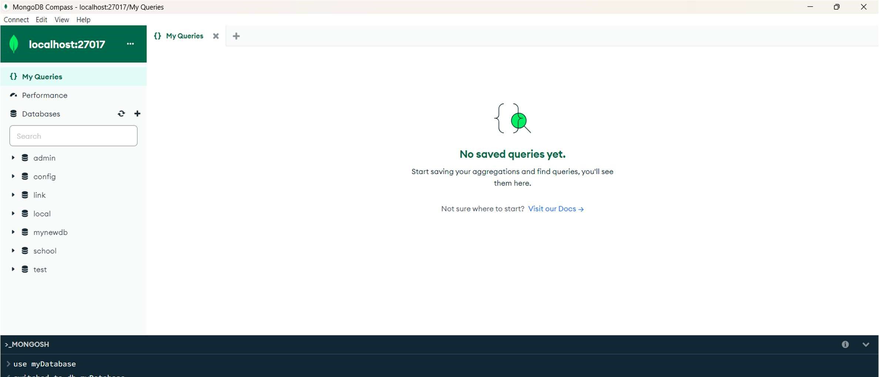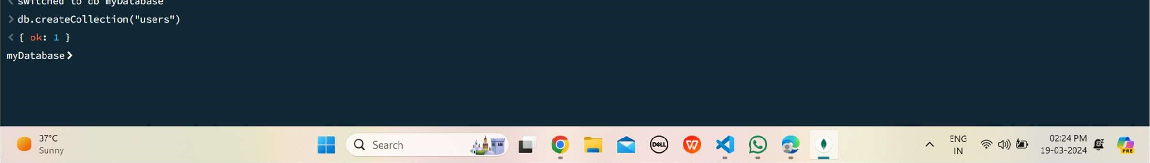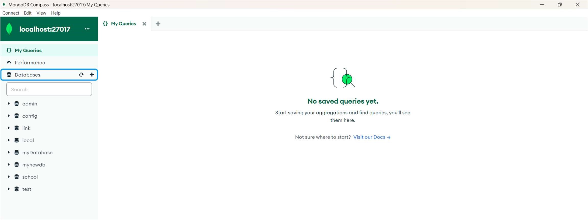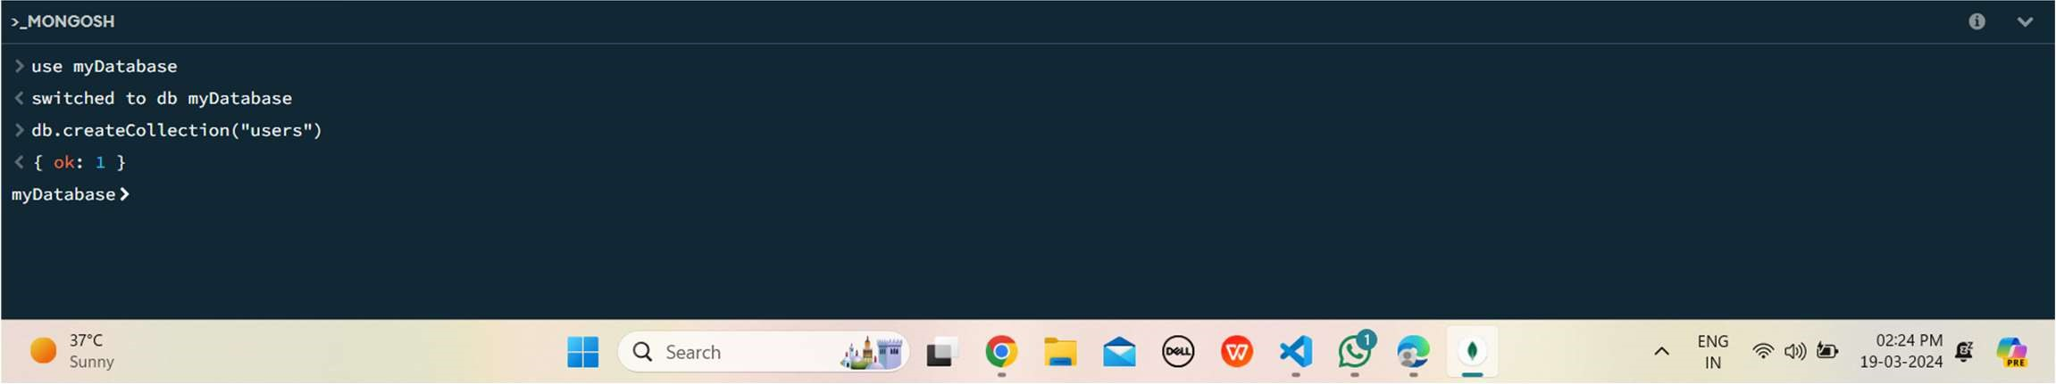

STEP 2 : Collection Creation: Create a collection named users within the myDatabase database.

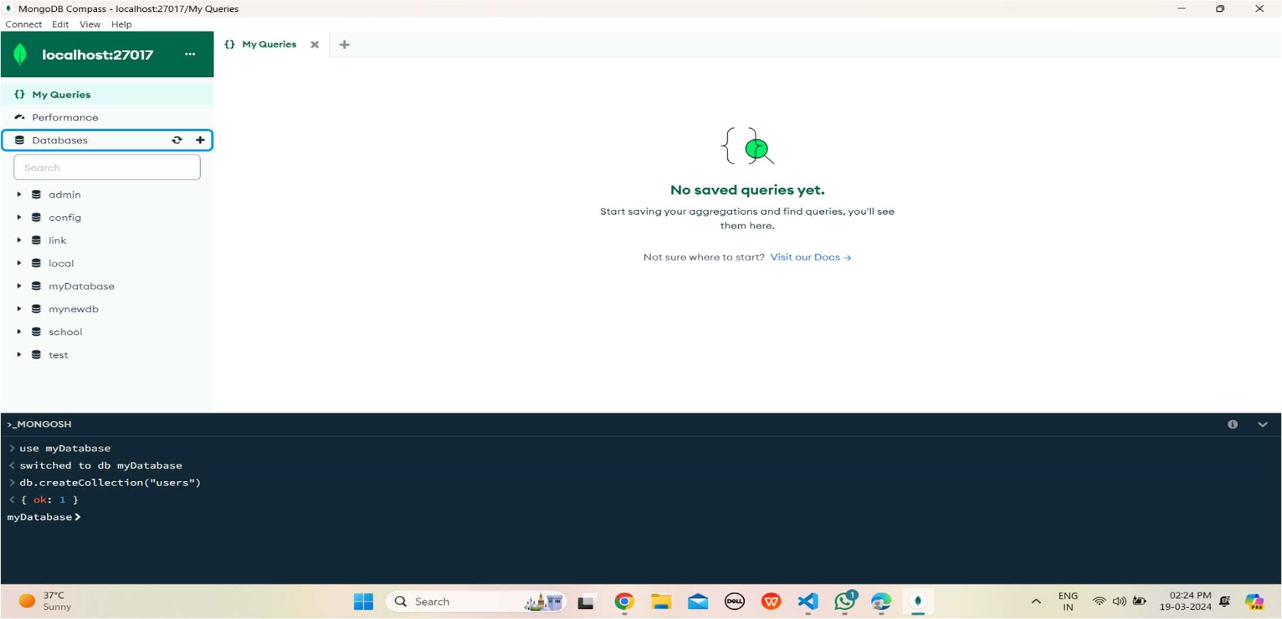

STEP 3 : Document Insertion: Insert at least three documents into the users collection, each representing a user with fields such as name, email, and age.

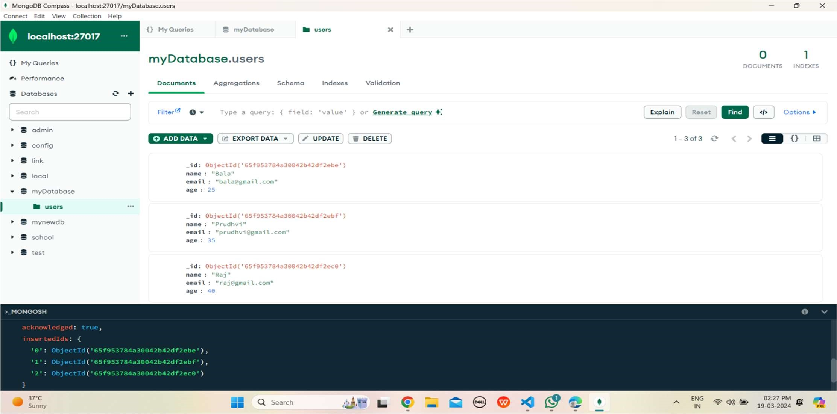

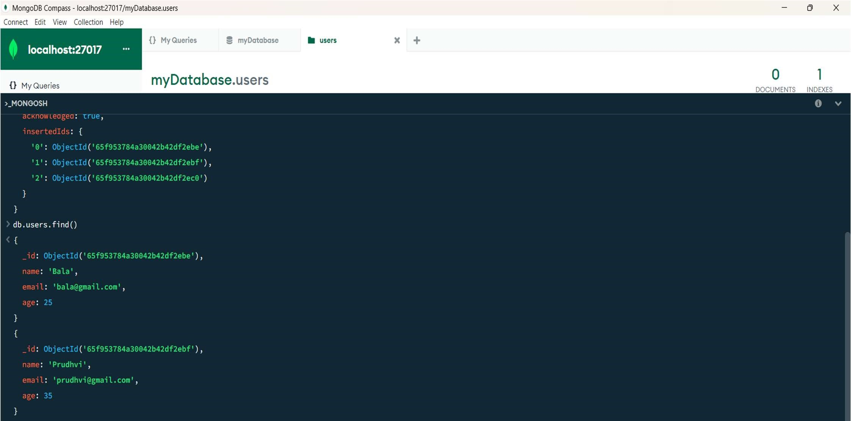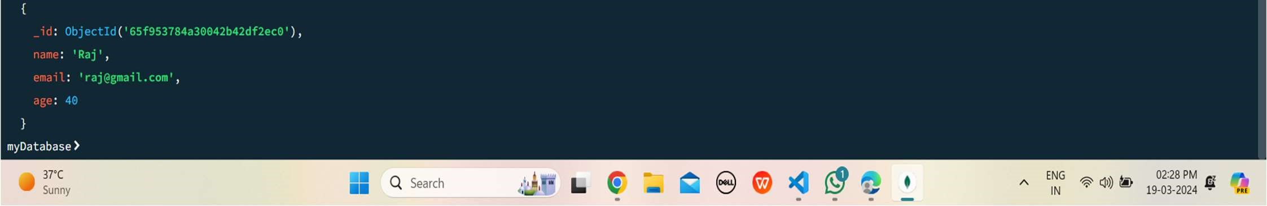

STEP 4: All users from the users collection.

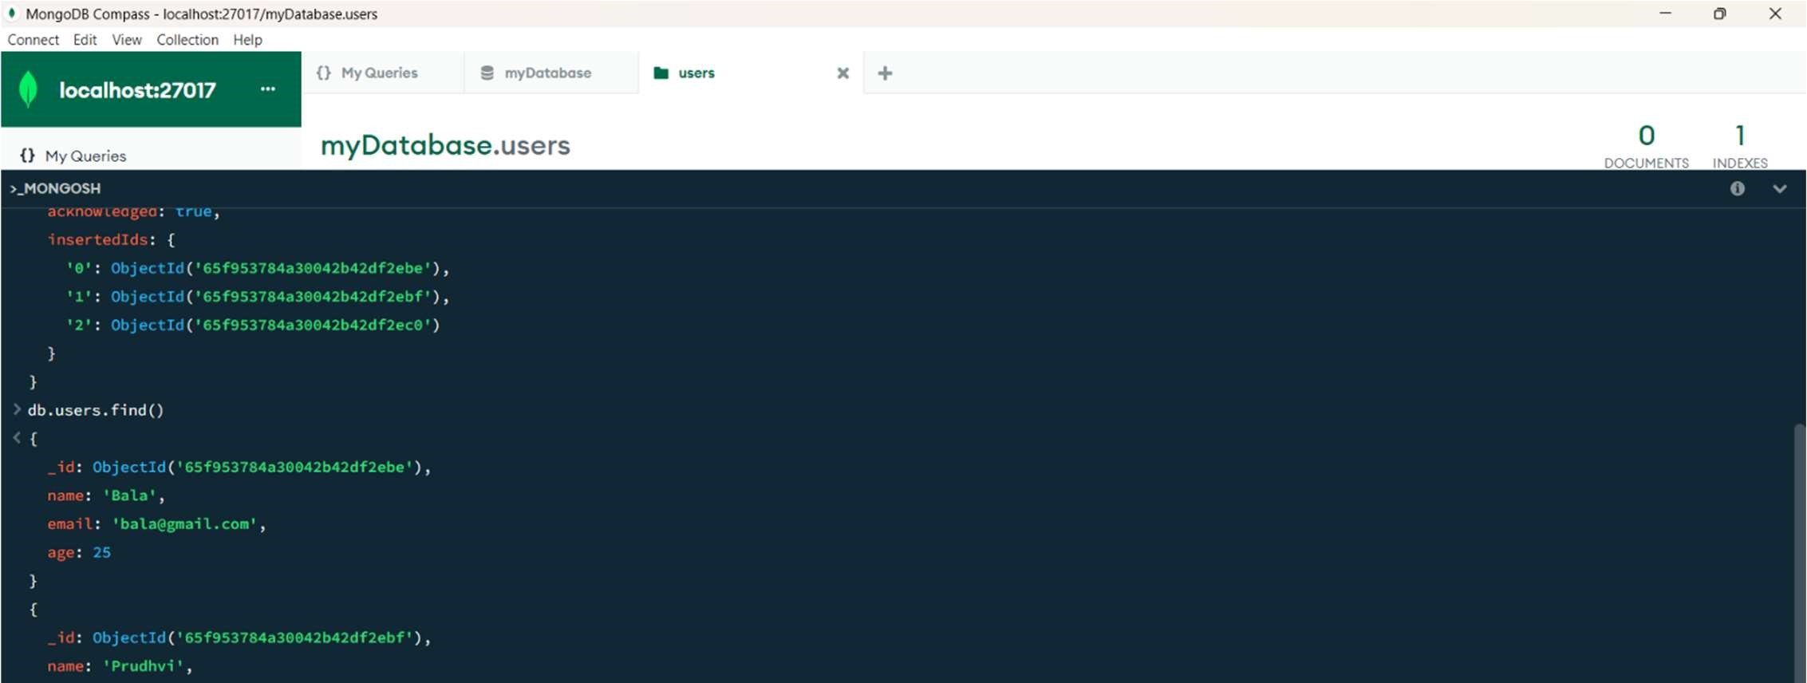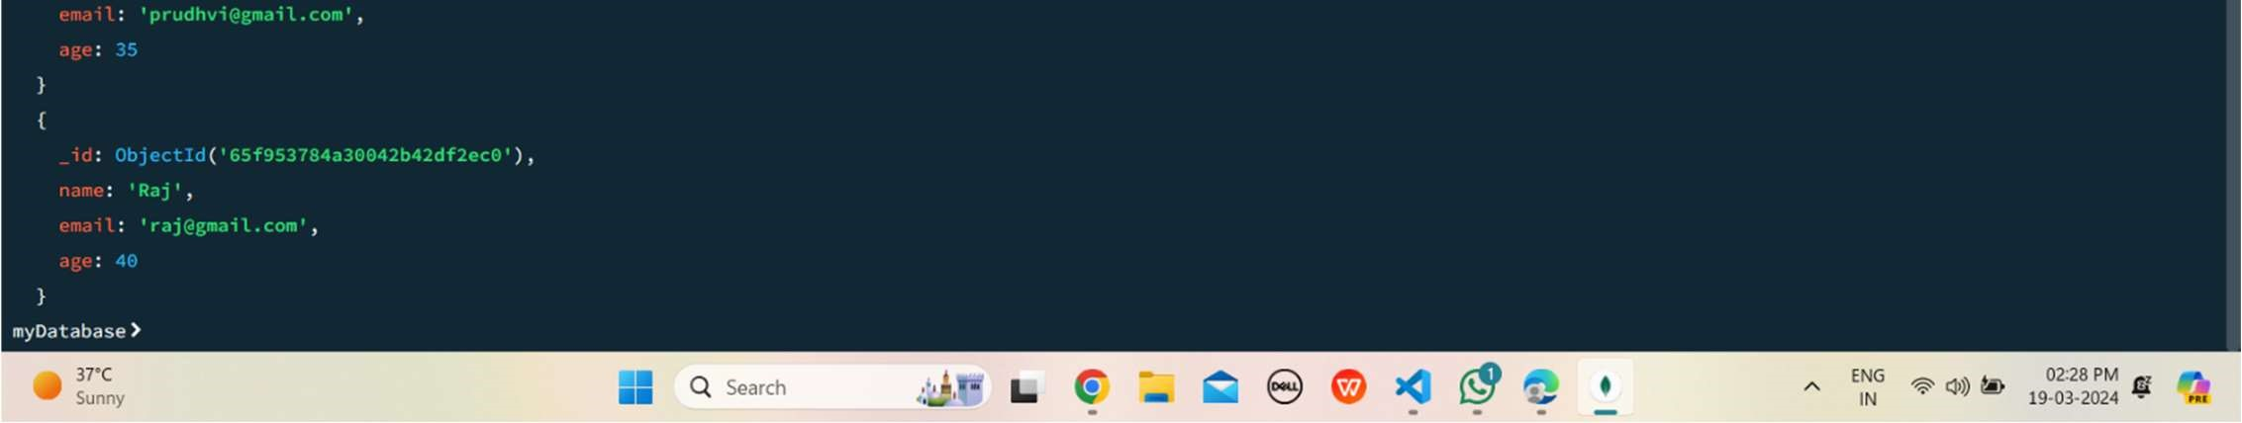

STEP 5 : Users with an age greater than or equal to 30.

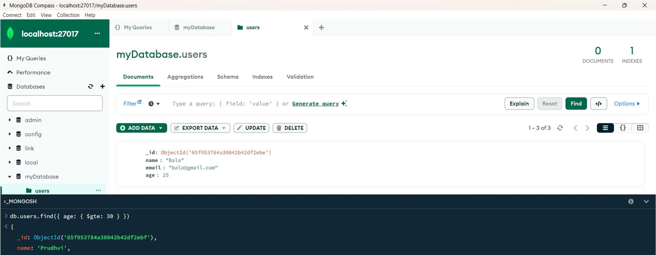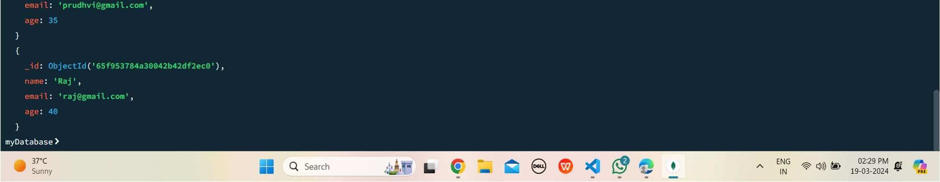

STEP 6 : Update Operation: Update the age of a user with a specific email address.

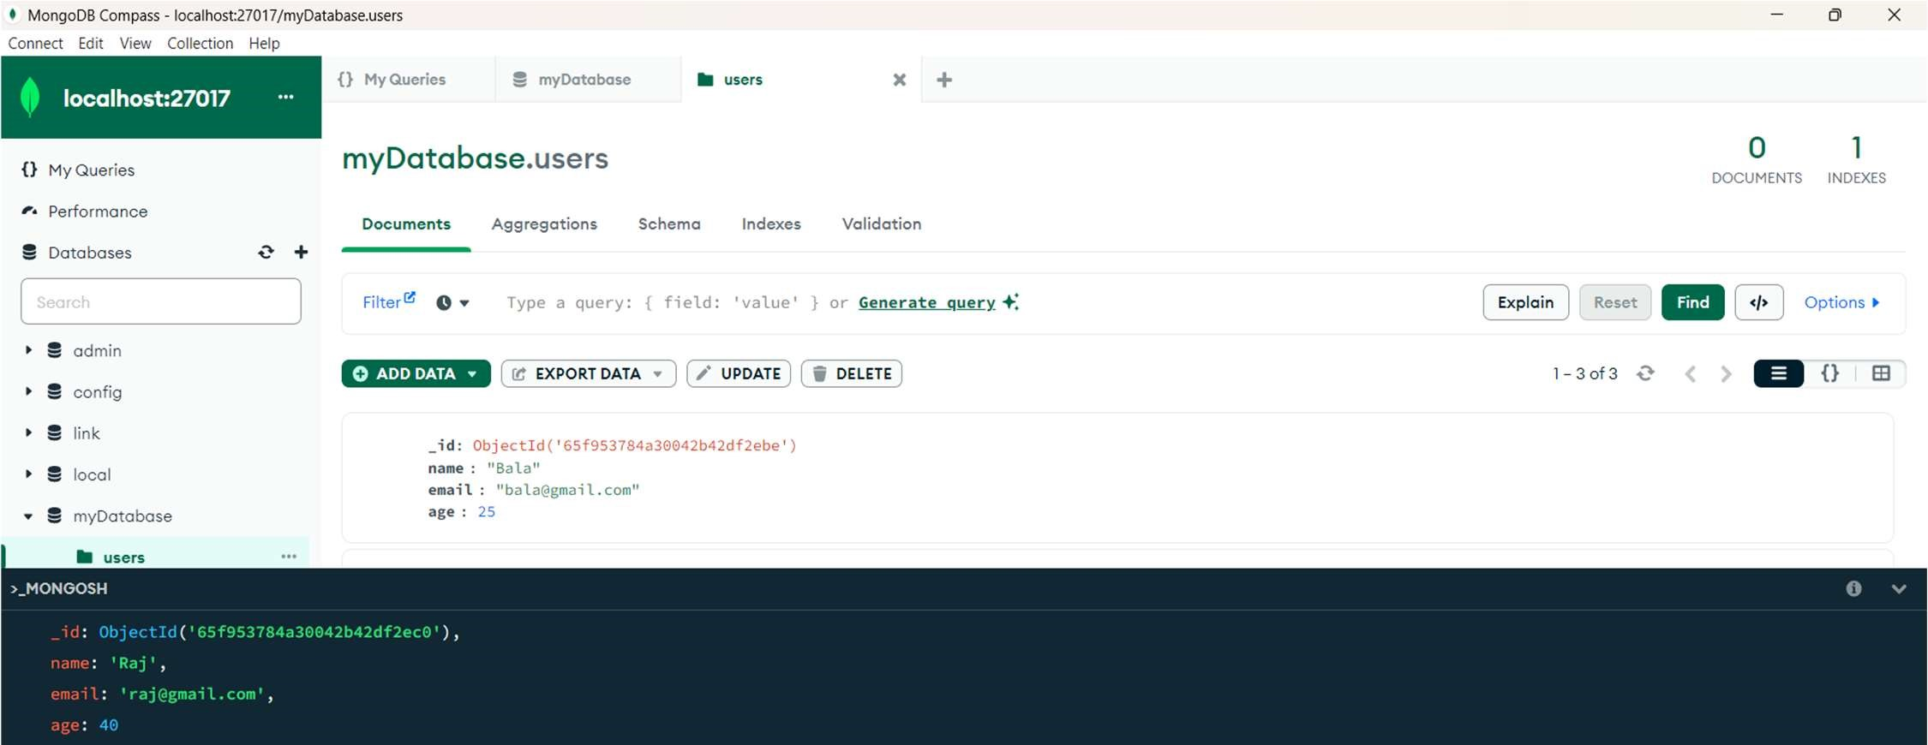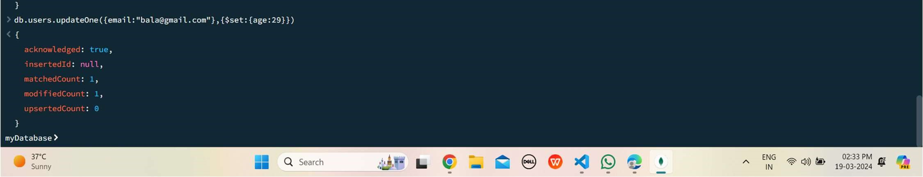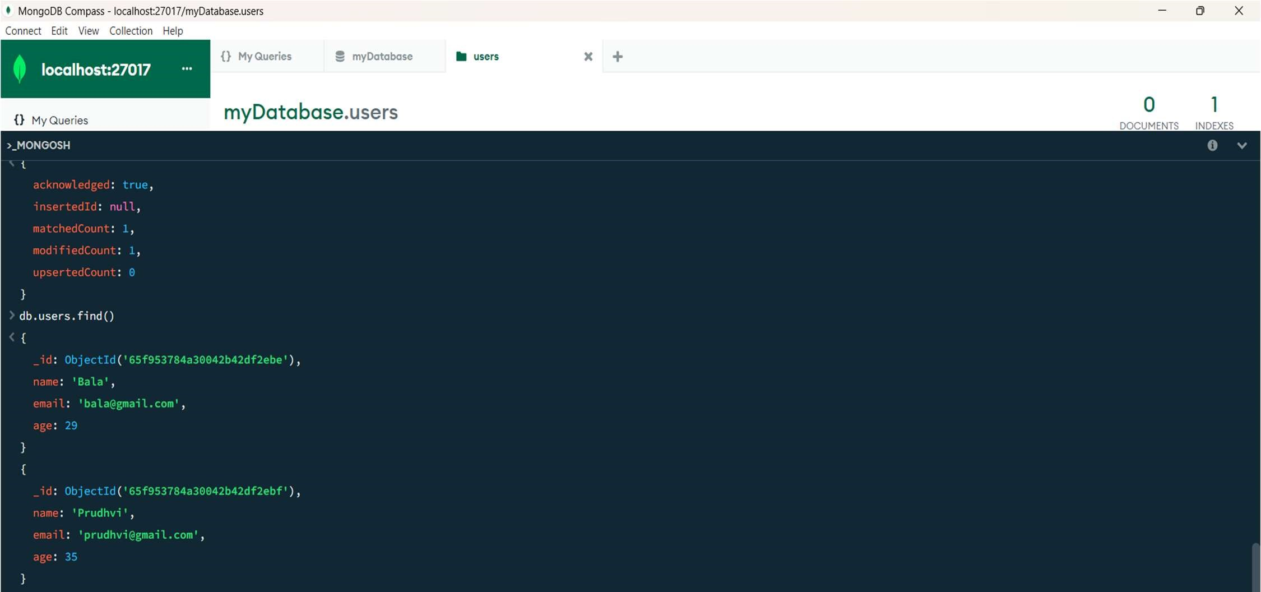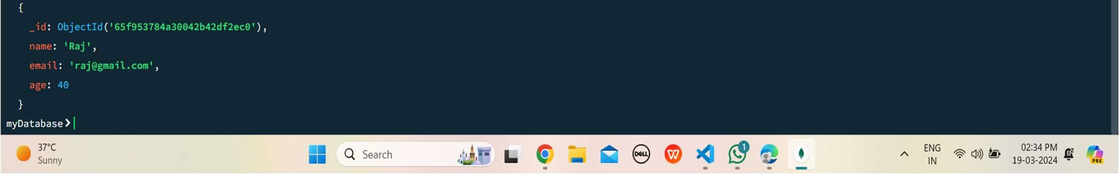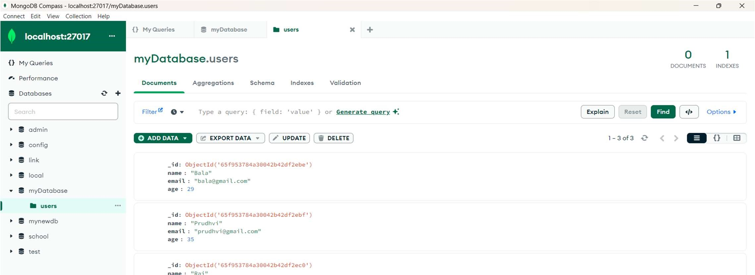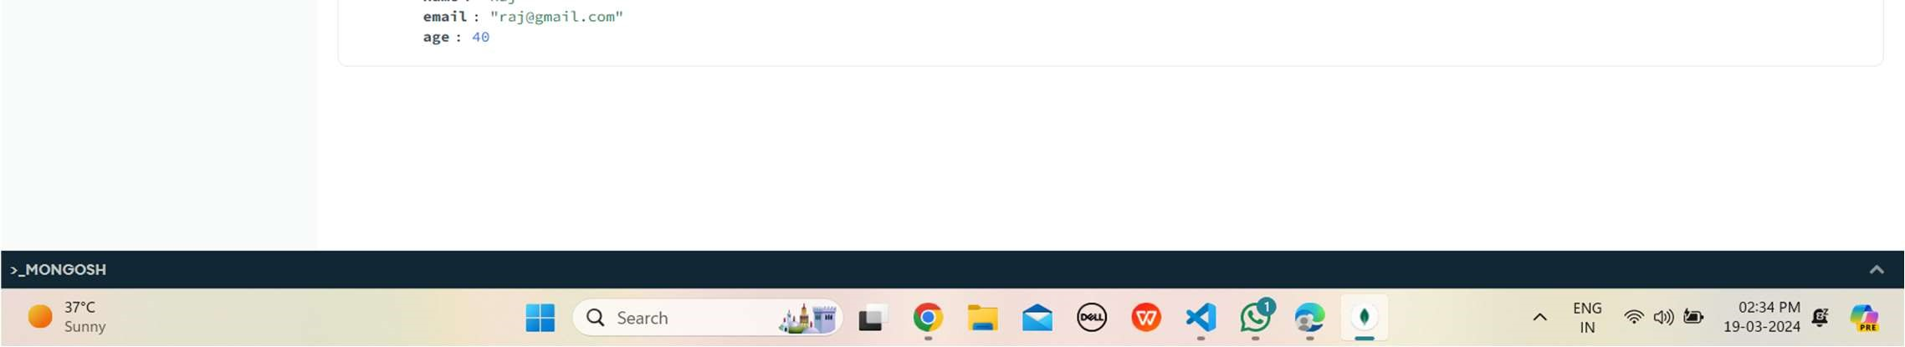

STEP 7 : Deletion Operation: Delete a user document based on a specific email address.

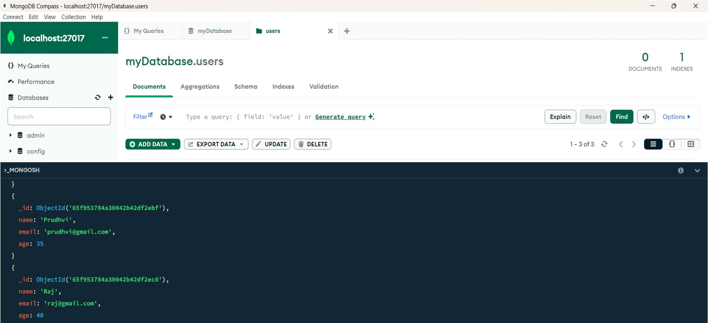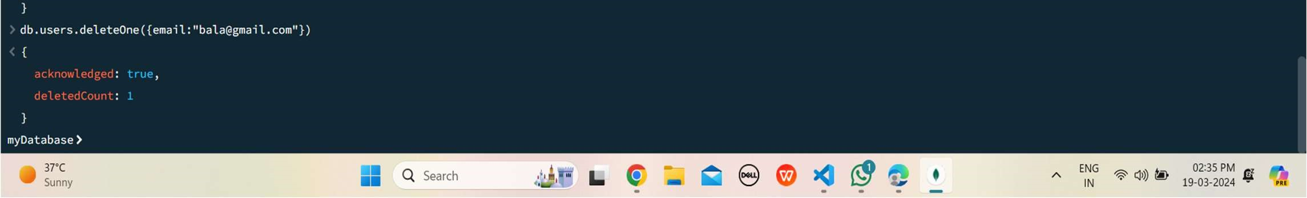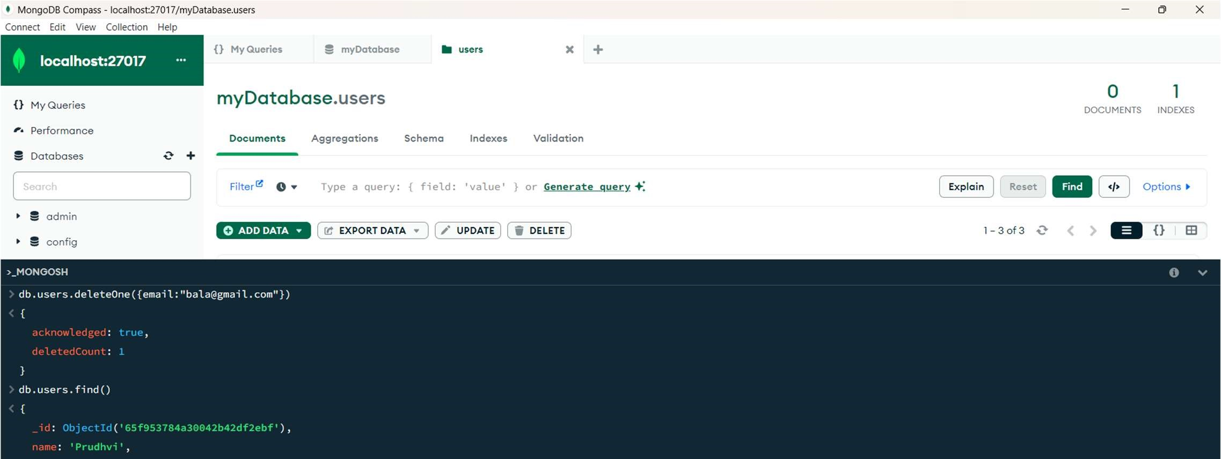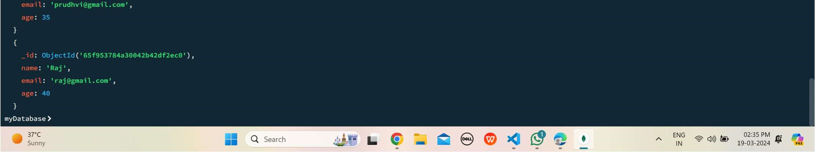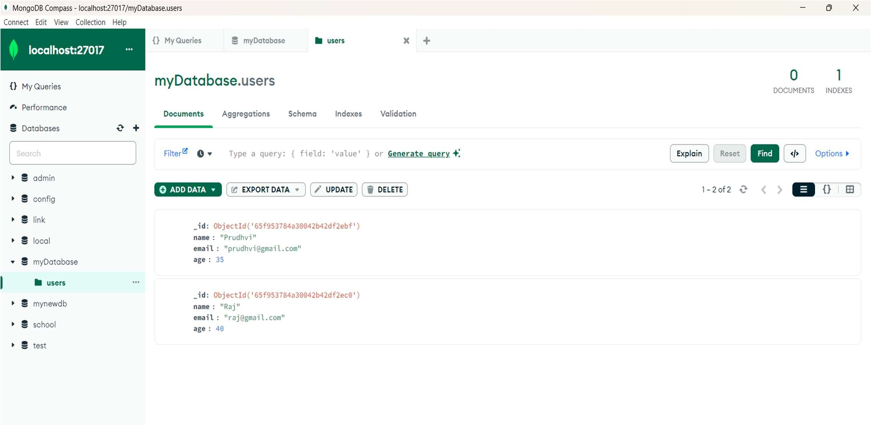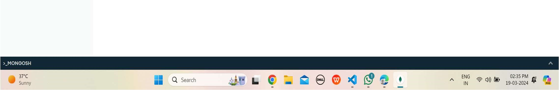

STEP 8 : Index Creation: Create an index on the email field of the users collection.

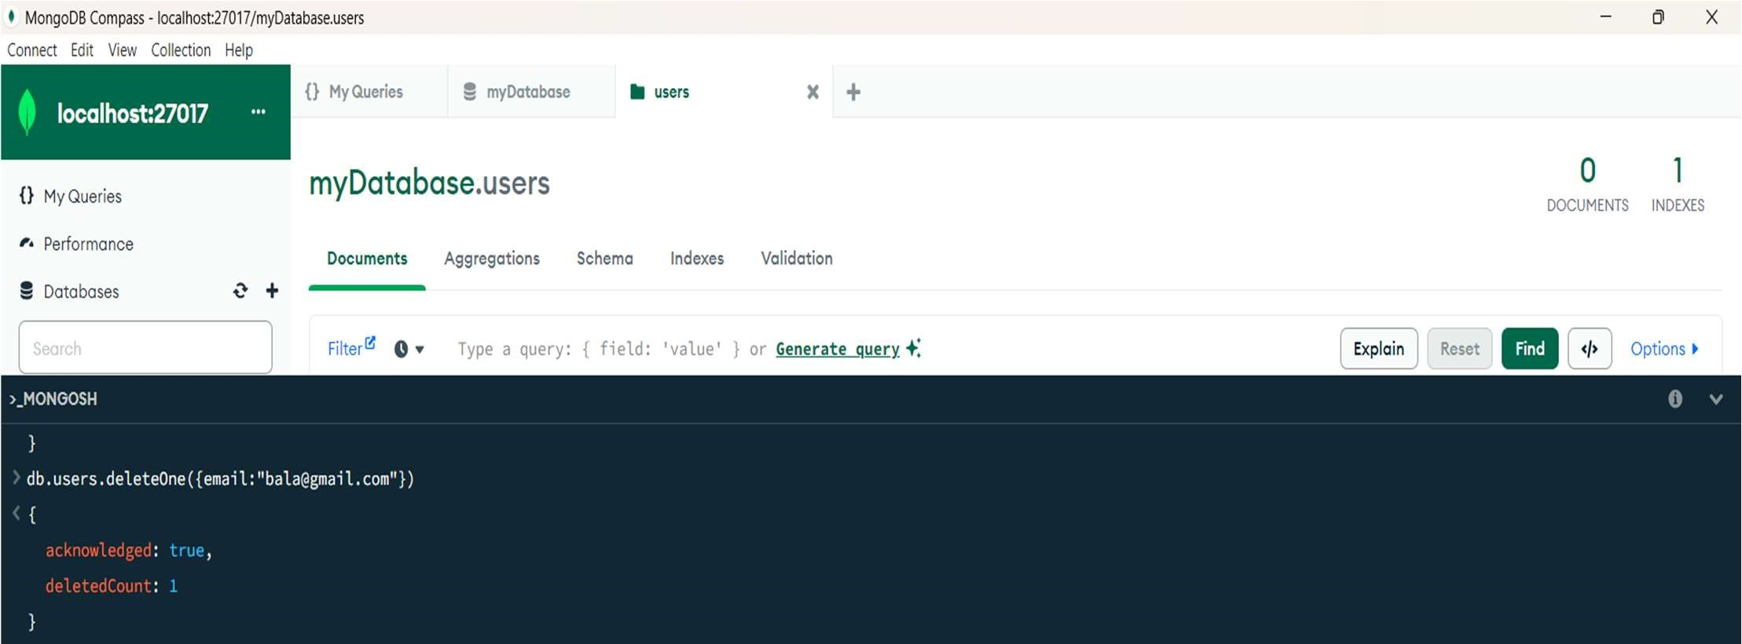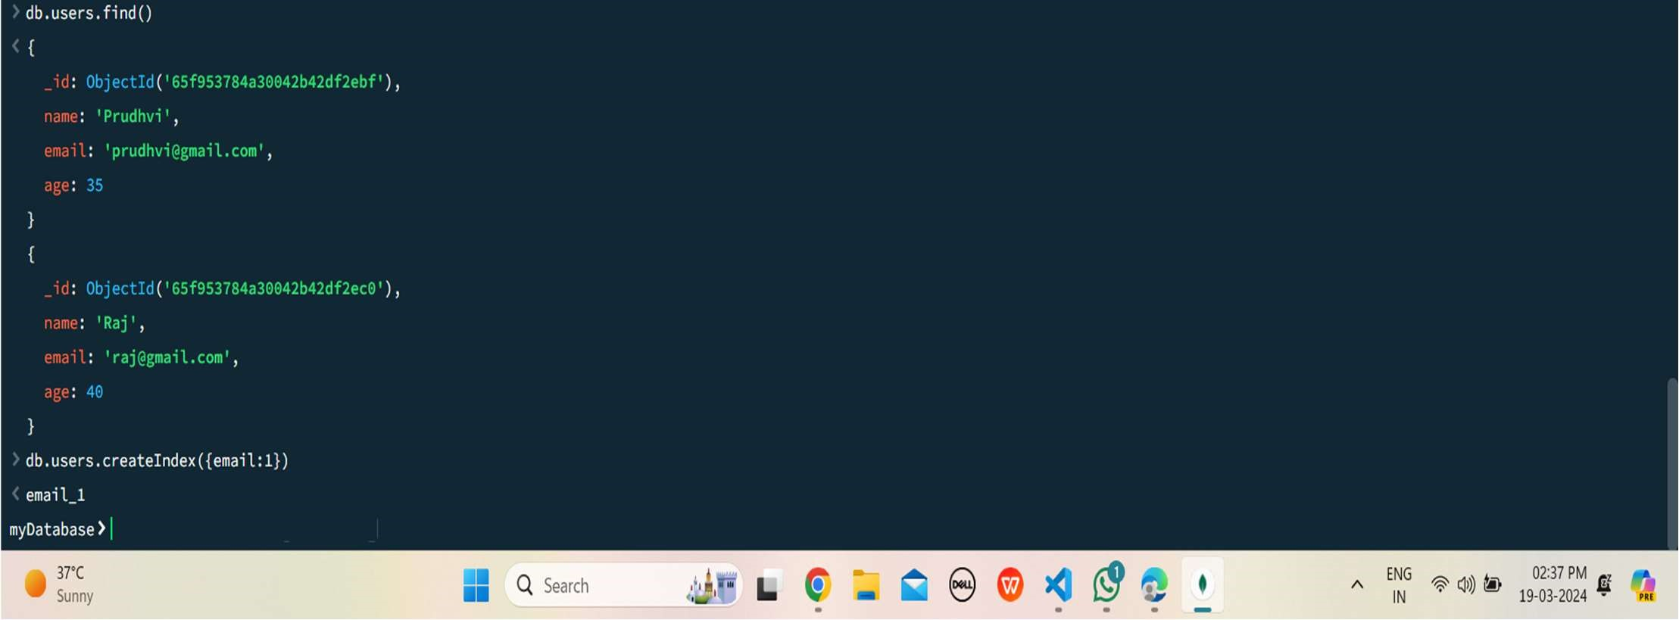

QUERIES:

1.USE myDatabase.

2.db.createCollection(“users”)

3.db.users.insertMany([{name:”chaitu”,email:”chaitanya@gmail.com”,age:25},

{name:”chaitanya”,email:”chaitanya@gmail.com”,age:35},

{name:”Reddy”,email:”reddy@gmail.com”,age:40}])

4.db.users.find({age:{$gte:30}})

5.db.users.updateOne({email:”chaitanya@gmail.com”},{$set:{age:29}})

6. db.users.deleteOne({email:”chaitanya@gmail.com”})

7.db.users.createIndex({email:1}).